Districts or Cities Screen
  - Purpose
    - This screen manages the information of different districts or cities.
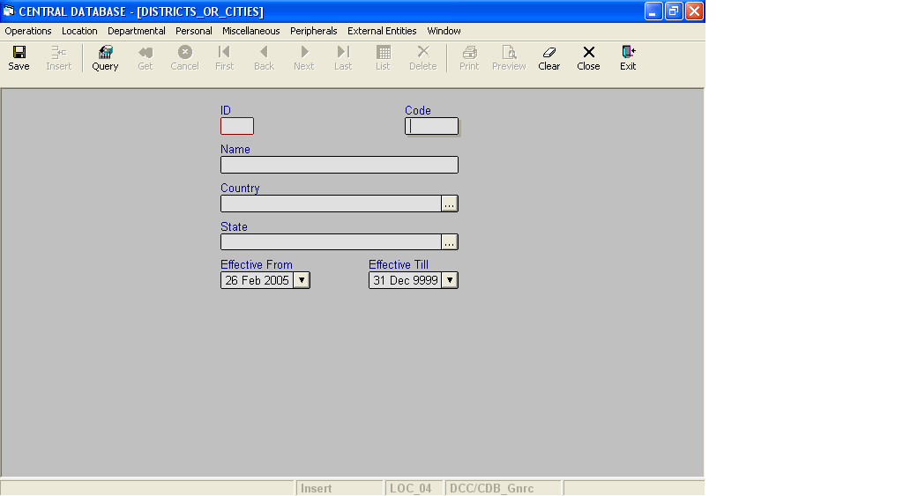

Layout as seen on opening of the Screen
  - Events associated
None
  - Modes
    - It will start in Insert mode.
    - It supports Insert, Query, Retrieve, Browse, List, New, Update and Reference modes.
  - Field specifications
    - Simple fields

 | Type | Length | Optional | Insert Mode | Query Mode | BrowseMode
ID | district_or_city_id | 4 | N | N.A. | Allow | Display
Code | char | 5 | N | Allow | Allow | Allow
Name | varchar | 35 | N | Allow | Allow | Allow
Country | Key |  | N | Allow | Allow | Allow
State | Key |  | N | Allow | Allow | Allow
Effective From | datetime | 8 | N | Allow | Allow | Allow
Effective Till | datetime | 8 | N | Allow | Allow | Allow
- Tabular Field Items

 | Type | Insert Mode | Query Mode | Browse Mode
P.O. Code | Key | N.A | N.A | Display
Post Office Name | Key | N.A | N.A | Display
P.O. ID | Key | N.A | N.A | Display

  - Simple Fields
    - ID
      - This is the District or City ID, which uniquely identifies all the District or cities.
      - This field will be automatically generated by the system.
      - The user will be informed of the generated ID as part of the message which will be shown on successful saving of information in Insert Mode.
    - Code
      - This is the code of the District or City.
      - It is user defined. It can be changed in Browse and Update Modes.
    - Name
      - This is the name of the District or City.
      - The name can be changed in Browse and Update Modes.
    - Country
a) This field specifies the Country to which the State of the District or City belongs.
v. State
a) This field specifies the State to which this District or City belongs.
vi. Effective From
      - This is the date since which a District or City is effective.
      - By default, the system will display the current date in Insert Mode.
      - Normally, it should not be a future date. This is the recommendation. System will display a warning, if future date is specified.
      - It cannot be later than the date specified in Effective Till.
    - Effective Till
      - This is the date till which a District or City is effective.
      - By default, the system will display 31-Dec-9999 in Insert Mode.
      - Normally, it should not be a past date.
      - It cannot be earlier than the date specified in Effective From.

f. Tabular Field Items
i. P.O. Code
a) It is the code of the post office, which comes under the district or city.
ii. Post Office Name
a) It is the name of the post office, which comes under the district or city.
iii. P.O. ID
a) It is the ID of the post office, which comes under the district or city.

- Lookup or Help
Field | Items of Information as will be shown | Remarks
Country | Name, Code | Only active Countries will be shown.
State | Name, Code | Only active States will be shown.
h. Action Buttons
None
i. Users / User Roles
CDB_Gnrc user is permitted to insert, update, delete and select District or City.
j. Other Considerations
- The combination of Code of the district, country and state should be unique.
- The combination of Name of the district, country and state should be unique.

